Requirements
The scope of the project for the print domain is to:
- Current state is that they’re in their own database, not in the other domains’ db
- Feature catalog is a DB has conformed, metrics, and semantic layer
- Experiment analysis is a DB as well, also has 3 layers
- 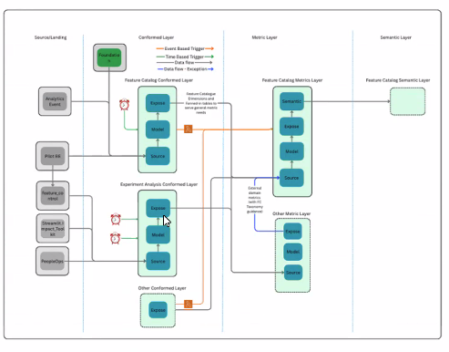
- Current state is
  - DB called feature catalog, 3 schemas: model, expose, and source
  - There is one DBT project for feature catalog
- Remodelling needs:
  - Add some surrogate keys to some dims
- Architecture
  - Create three new layers: the conformed layer, the metrics layer, and the semantic layer.
    - Feature catalog conformed Layer - rename the current feature_catalog database to be the conformed layer
    - Feature catalog metrics Layer - Star schema dimensional models
    - Feature catalog semantic Layer - Governed AI-ready interface via Snowflake Intelligence
  - These layers will sit on the same SF account as the current tables do
  - 16 tables will be moved from the current database to the new feature catalog metrics database
  - 3 fact tables require creating surrogate keys inside them for other dimensions, but will be kept in their current database
  - Creation of semantic views in out of scope
- Transformation
  - No dbt remodelling required, just repointing of 16 tables’ models to their new database location
  - Note that the DbT model to table relationship is one to one
- Orchestration:
  - Need to switch current orchestration (which is in kubernetes cron jobs) into airflow
  - Need to implement event triggered airflow orchestration based on foundation layer jobs
- Migration:
  - Not needed
- Governance:
  - No requirement
- Documentation:
  - Provide the solution design document of the migrated DBT project and data model and the new objects created.
  - Provide document / guide for downstream consumers to re-point to new world
  - Go to production guide

Questions
- If the new objects are created, will the old ones (light blue) sit in the old database?
- Is the feature_catalog dbt namescpace in the monolith or in the pilot domain’s own dbt project?.
  - No its its own
- Is the scope to remodel the current data models or keep as is and move into conformed / metrics as specified in page 4?
- 3 new tables + their DBT models need to be created?
  - 1 new table + adding sIDs to 2 others
- 16 tables to be modified - data and dbt modelling or just dbt?
  - No, data models won’t change
  - DBT models will repoint the dark blue tables to their new database location (which will be feature_catalog_metrics db)
- When you say “expose foreign keys”, what do you mean by that?
  - Expose is not sharing with others, it’s just adding the attribute
- Creation of 3 semantic views
  - No semantic views. It is descoped
- How many upstream dependencies exist for each of the 4 report pipelines? Are they all within the print domain or cross-domain?
  - foundation
- Are we intending to migrate old table data to new data model?
  - No migration
- What is the current data volume (row counts, storage size) for each key table?
  - irrelevant
- Are there any governance policies to be implemented?
  - New metrics database for feature_catalog
  - But no governance controls whatsoever
- Are there existing metric definitions documented, or do they need to be created from scratch for the semantic layer?
  - Will be out of scope
- Do we have a clear view of what needs to be made available in the semantic layer?
  - Will be out of scope
- What type of assistance are you looking for? Full ownership?
  - End to end solution
  - Designing the solution high level (solution architecture)
  - Designing the new DBT projects and data models (data architecture)
  - Getting approvals
  - hands on
  - Includes testing
  - No productionization
  - Go-to-production guide doc is needed
- Add assumption of DEV env readiness for all domains
- Add assumption about design approval
- Add assumption that model triggers are already available in airlof
- Add issue that approach is not finalized
- Each table ion diagram has one dbt model
- Orchestration:
  - Needs to be in airflow
  - Needs to be event triggered from foundation
  - Data platform tooling that is being used to manage dbt is not the one other domains
  - Platform tool to manage DBT models is V2X for all others, while it’s V2 for pilot domain. There are V1, v2, and v2x. Is this going to impact orchestration?
- Do you have the list of models / mapping between models and tables?
  - One to one
- What’s the dbt models’ level of complexity?
  - 10% complex but those don’t need changes
  - 90% medium among which are the oners that doi need changes
  - Assume all changes are medium then

